

Date: __________________ Teacher Name: __________________________________

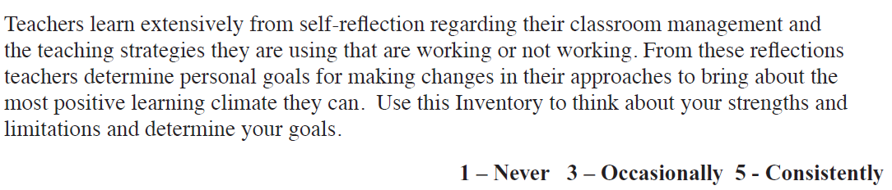

Building Positive Relationships with Children
- I greet my students upon arrival with personal and positive greeting (e.g., using child’s name). | 1 2 3 4 5
2. I interact with my students with warmth, caring and respect. | 1 2 3 4 5
3. I speak calmly and patiently to my students. | 1 2 3 4 5
4. I listen to my students and avoid judgmental or critical responses. | 1 2 3 4 5
5. I provide sincere, enthusiastic, and positive feedback to my students about their ideas. | 1 2 3 4 5
6. I personalise my communications with individual students (e.g., asks about life outside of school, their special interests, hobbies or favourite books, shares something personal about self to children acknowledges birthdays). | 1 2 3 4 5
7. I spend special time with each of my students (e.g., on playground, during meals, unstructured time). | 1 2 3 4 5
8. I send home positive message cards to parents to tell them about their children’s successes or accomplishments. | 1 2 3 4 5
9. I make positive calls to parents to tell them about their children’s successes or positive behaviour. | 1 2 3 4 5
10. I communicate belief to my students that they can succeed and promote their positive self-talk. | 1 2 3 4 5
11. I individualise each student’s needs, interests and abilities (e.g., planning activities or stories based on special interests of children) | 1 2 3 4 5
12. I help children in the classroom to appreciate each other’s special talents and needs. | 1 2 3 4 5
13. I am child-directed in my approach and behave as an “appreciative audience” to their activities. | 1 2 3 4 5
14. I avoid question-asking, directions and corrections when possible. | 1 2 3 4 5
15. I share my positive feelings when interacting with my students. | 1 2 3 4 5
16. I invite my students to help with classroom jobs and responsibilities. | 1 2 3 4 5
17. I adjust activities to be developmentally appropriate for each child. | 1 2 3 4 5
18. I engage with children in ways that provide teacher modelling, prompting and guided practice. | 1 2 3 4 5
19. I work to convey acceptance of individual differences (culture, gender, sensory needs) through diverse planning, material and book selection, and discussion topics. | 1 2 3 4 5
20. I participate in activities with my students. | 1 2 3 4 5
Future Goals Regarding Ways I will Work to Build Relationships with Identified
Students:

Building Positive Relationships with Parents

1. I set up opportunities for parents to participate or observe in the classroom. | 1 2 3 4 5
2. I send home regular newsletters to parents and positive notes about their children. | 1 2 3 4 5
3. I have a regular call schedule for calling parents to give them positive messages about their children. | 1 2 3 4 5
4. I have regular posted telephone hours or times parents can reach me. | 1 2 3 4 5
5. I schedule parent evenings/ meetings to share classroom activities with parents and to present ideas for carrying over classroom activities at home. | 1 2 3 4 5
6. I consider parents’ for ideas, materials and support for classroom activities. | 1 2 3 4 5
7. I recognise the importance of partnering with parents and collaborating in order to develop strong connections with children. | 1 2 3 4 5
Future Goals Regarding Involving Parents:

